**Online Shopping Trends and Customers behavior**

Data

<https://www.kaggle.com/datasets/zeesolver/consumer-behavior-and-shopping-habits-dataset>

**E-Commerce shopping trends**

Consist of one table contains 18 columns

**Analysis Stages**

**1- Extract Data**

Extract data as CSV file to Excel sheet using power query

**2- Transformation**

* Split the table to two tables Products an dimension table and Customers as a fact table to reduce redundancy
* Create Product-id in products table as a primary key and add it in customers table as a foreign key
* Check on data types
* Remove duplicates
* Check if there are any null values (No Nulls)

**Add columns**

* **Sales =** purchase amount * purchases frequency
* **Age categories : age < teenager , 18- 26 youth , 26-50 adults, >50 seniors**

**3- Analysis**

**DAX**

* **Average Order Value (AOV) per customer**

AOV= Total_Sales / Transactions

* **Rank products by total sales**

RANKX(ALL(Products[Item Purchased]) , CALCULATE([Total Sales]) )

### **Discounted Sales %**

the percentage of total sales that came from discounted transaction

DIVIDE(

SUMX(FILTER(Customers, Customers[Discount Applied] = "Yes"), Customers[Sales]),

SUM(Customers[Sales])

)

* **Percentage of sales generated by using promo code**

DIVIDE( SUMX( FILTER(Customers , Customers[Promo Code Used]

= "Yes") , Customers[Sales] ) , [Total Sales] )

* **Percentage of customers used promo code**

COUNTX( FILTER(Customers , Customers[Promo Code Used] = "Yes" )

, [Customer ID] )

**Products and categories preferences**

* Which products or categories are most popular?

Clothing and Accessories are most popular, and

top products made purchases are Jewelry , Blouse, Dress

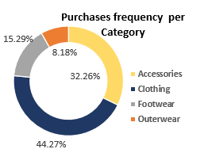

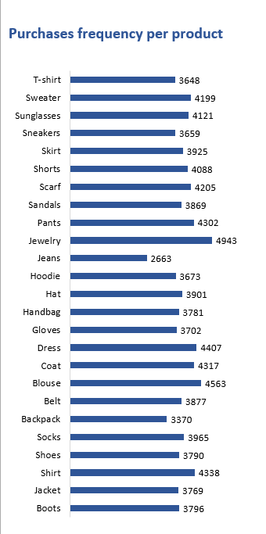

* Which categories are most popular in each season ?

Fall: Clothing 42 % , Footwear 38.59 %

Spring: Accessories 62.8%

Winter: Clothing 100 %

Summer: Clothing 34.34% , Accessories 31.31 %

**Seasonality & Time Trends**

* Sales per season

Spring is the most season generate sales , it`s generated 40 % of total sales

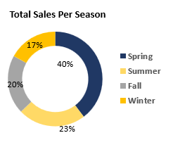

**Customer Behavior**

* purchase cycles intervals

Most intervals that customers prefer to buy are Every 3 months and Annually

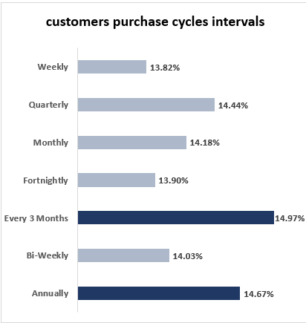

* Average spend per order (AOV )

Average purchases value that customers spend per order is **1518**

**Demographics Impact**

* Influence of age categories, gender, and location on shopping habits
* **68%** of Customers in this business are **Males** and also they are generate purchases more than females
* **Seniors** and **Adults** constitute the largest percentage of total customers and also generate the largest percentage of purchases.

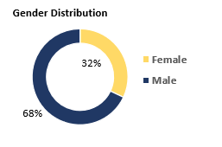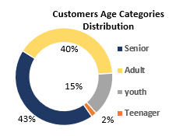

**Payment & Shipping Trends**

* Preferred payment methods

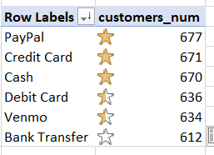

* Shipping methods customers choose most and sales generated by each method
* Most used shipping method is **Free Shipping,** but high sales are generated by the **Standard method.** This is because customers who use the Standard method have highest purchases frequency than who used other methods.

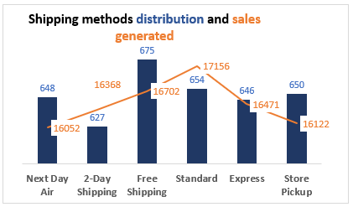

**Discounts & Promotions**

* How much users use promo code ?

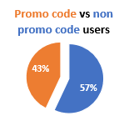

* Customers, Purchases frequency and Sales with promo code

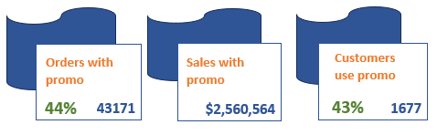

* How much promo code drives sales per season ?

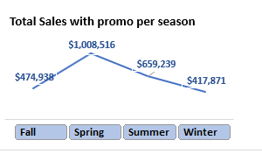

**Recommendations**

* Customers prefer purchasing in Spring, so we should focus on this time by make offers and marketing campaign
* In marketing campaigns we should target seniors and adults because they are constitute the largest percentage of our customers
* Make sure we have enough amount of Accessories and clothing because they have many orders specially in spring and winter
* Take feedbacks from users about Outereware to understand why they don’t record purchases to solve the problem and increase sales
* 44% of total purchases is generated by promo code users and this technique is very good and enhance sales, so we should focus on promo code and discount in our marketing campaigns